Skylar Wurster

Professor Jian Chen

February 24, 2019

CSE 5544 Data Visualization

Assignment 3 Observations

**How have the encounters reduced between the first and the second three months?**

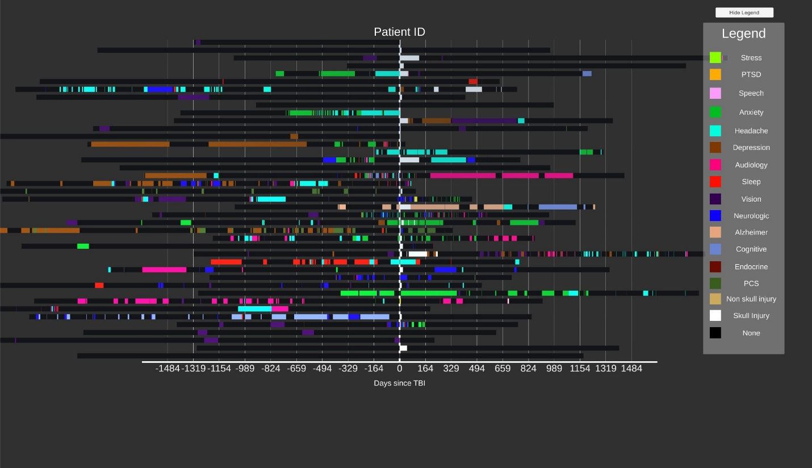

From the visualization, it is difficult to find a trend in the number of visits in the first three months and the second three months. This is because the “None” encounter type is black, and so it is difficult to tell how many doctor visits occurred in a black bar. This is a limitation of the design chosen – we lose details that are in events that don’t have an encounter type.

One option to fix this would be to have a border or stroke around the bars for each encounter. This would be useful for non-dense areas of the graph. If zoomed out like this, however, dense areas with a border might interfere with visual quality and clarity, making it unclear how many events truly happened in one area until zoomed in.

Another drawback to the current visualization is that the x-axis remains static and doesn’t provide a helpful reference. The days from time 0 are arbitrary and mean little to a viewer. If a user could change the x-axis labels interactively, that would allow for easy comparison between the first 90 days and the second 90 days.

A helpful aspect of this visualization is the option to zoom and pan.

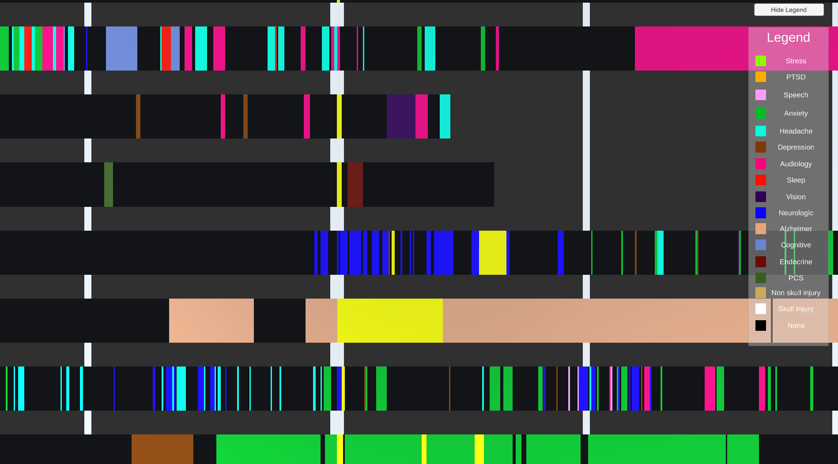

Above is a zoomed in portion of the graph at time 0. We can observe encounters more closely and have improved mouse accuracy for the hover text.

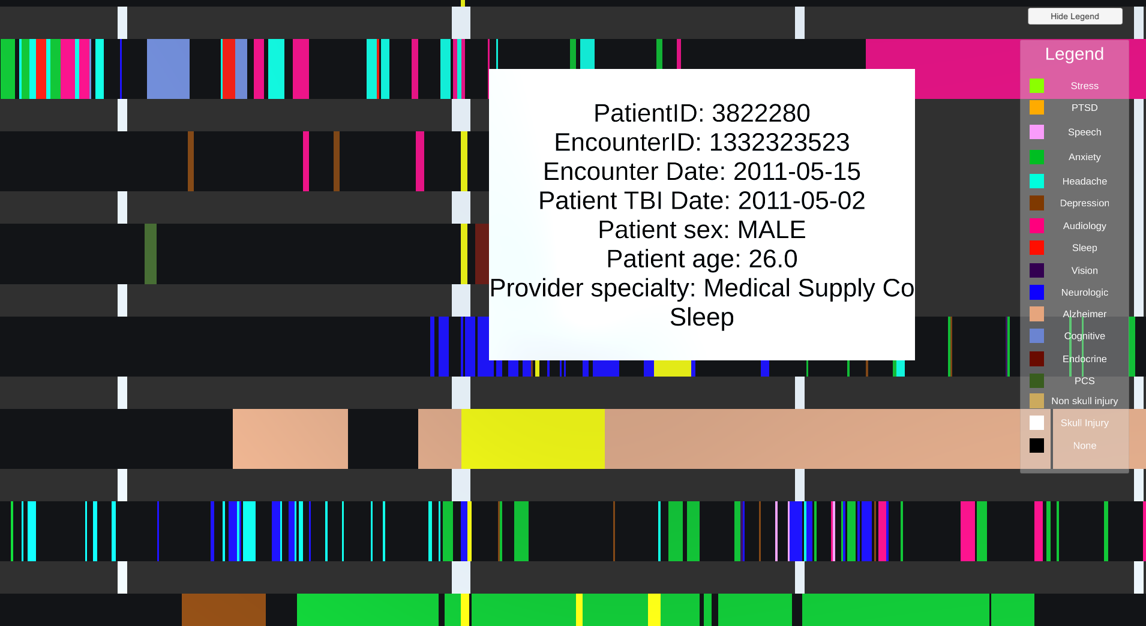

Though this doesn’t help with the comparison of the first and second three months, this does allow for details on demand.

Another way to compare the first and second three months is through the color of the bars. The right side holds a legend, which maps color to the encounter type. This makes it easier to see trends that develop. For instance, take these three examples.

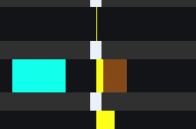

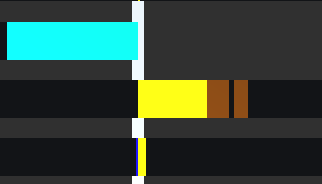

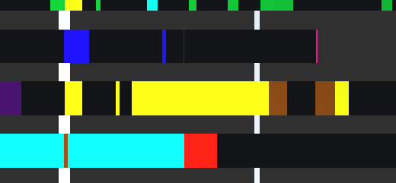

In these three examples, we see a yellow bar, which indicates “TBI_encounter_flag”, and it is then followed with a brown bar, indicating “headache”. This can allow a viewer to find trends like this in the data, though not very well. An improved cohort or clustering algorithm for sorting the patients on the y-axis would illuminate trends like this better, and is suggested to improve this visualization.

**Extra credit**

Interactive x-axis:

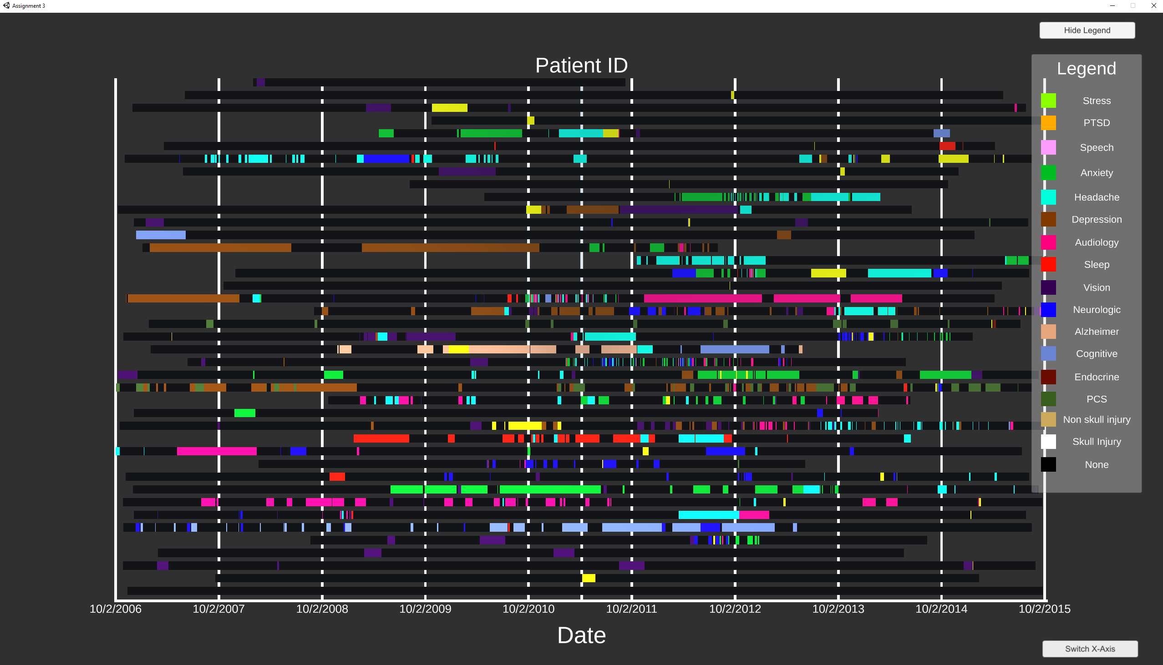

After all data is loaded, the button on the bottom right labeled “Switch x-axis” may be clicked to rearrange the data by absolute date, instead of by relative days since TBI. Clicking the box will swap between the two modes, changing the x-axis labels as well.

Ordered lines by date:

Each subsequent event in the line is ordered by date. That is, encounters further left on the bar graph happened earlier in time, and moving to the right the dates become more recent.